

<Molten Cave>

Project Report

DT282

Web Development 1

**Raghav Bansal**

School of Computer Science

Technological University Dublin

**19/12/2020**

Declaration

I hereby declare that the work described in this dissertation is, except where otherwise stated, entirely my own work and has not been submitted as an exercise for a degree at this or any other university.

Signed:

Raghav Bansal

Raghav Bansal

19/12/2020

Table of Contents

*1.* Problem Description 4

*2.* Research 4

*3.* Technology Selection and Site Architecture 4

*4.* Low Fidelity Prototype 4

*5.* Development Plan 5

*6.* Testing Plan Error! Bookmark not defined.

*7.* Site Evaluation Error! Bookmark not defined.

*8.* Deployment Error! Bookmark not defined.

Appendices Error! Bookmark not defined.

# Problem Description

This website is based on a restaurant named as MoltenCave. This website is for a food ordering. I think it will be a unique idea to make a website on a restaurant and food items. All pages are connected to each other and user will find information on all of them. Each page will focus on a restaurant what they provide, how they provide a dish, way they provide. I Assume there are some big branches of this restaurant in different countries. There are 5 pages, Home, Variety, Service, about us, Contact us. Each page explains the food at its best followed by images and videos. Many websites on internet just provide you food, but this website will show dishes that are most famous in all over world and eaten by many people and will give some Fun-Fact.

# Research

Before starting this website, I did some research what content I should make, then I choose food. Now I have to find some source or idea from other websites, and they helped me a lot. Website like Dominos.com, Deliveroo.com, Swiggy.com, Zomato.com. I did not go to any restaurant website because website like swiggy will show a full content to restaurant and for layout design I observe that your nav should look same throughout the website. Each website has its own images, its own content but the theme is quite attracting. I also decide to make my nav bar same and will put some images and video that will present my idea.

# Technology Selection and Site Architecture

Here it is used HTML 5 and CSS 3. This site is accessible by users on any available platform - tablet, laptop, phone, etc. It adapts as it is responsive to the viewing device.

It will resize itself.

# Low Fidelity Prototype

Let me show you Wireframes of my pages

1- Home Page

2- Variety page

3 - Service Page

4- About Page

5- Contact page

6 – Login Page

# HOME PAGE

VARIETY PAGE

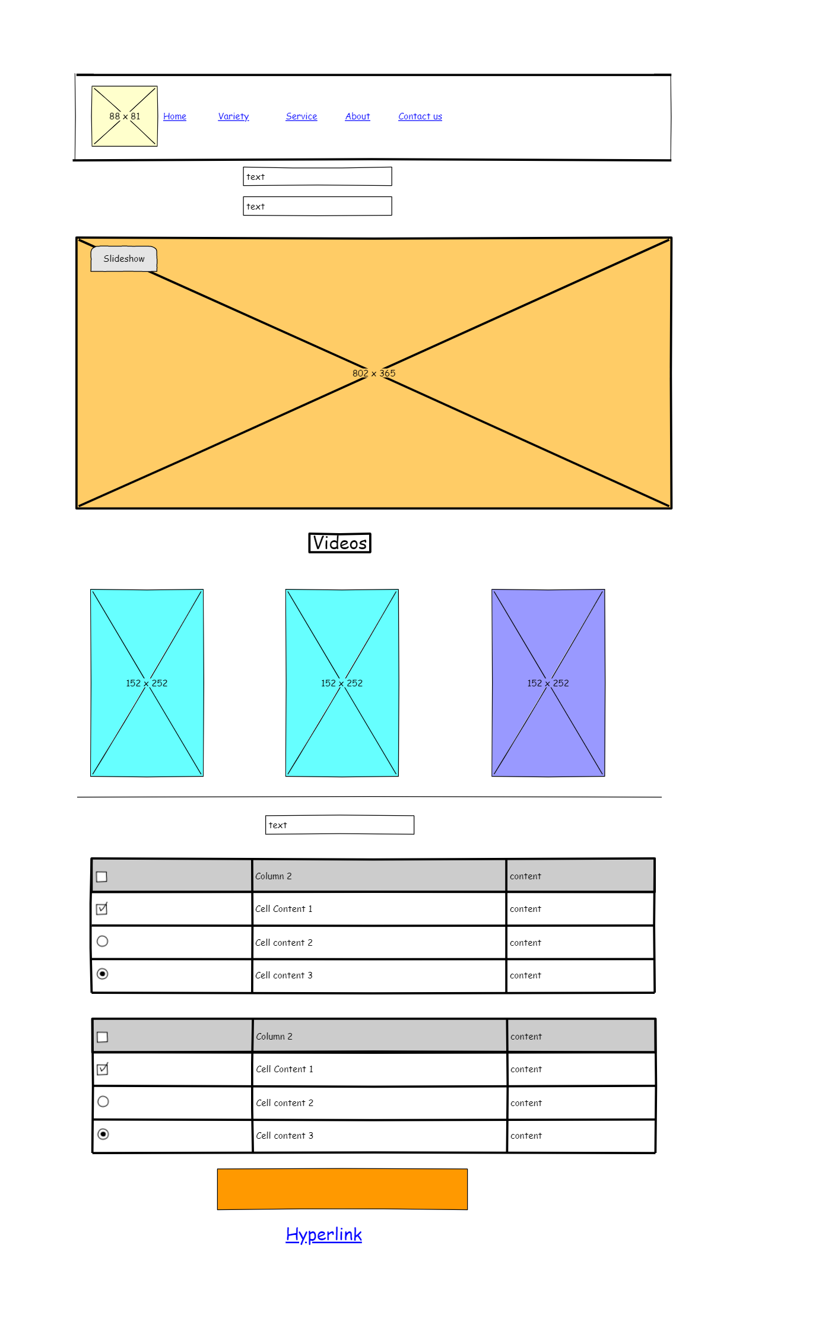

SERVICE PAGE

ABOUT PAGE

CONTACT PAGE

LOGIN PAGE FROM HOME PAGE

Development Plan

The website is created with five pages in total. The top of each page has a navigation bar (also known as menu bar) which provides an easy access to switch to different pages. All the pages have a footer at the bottom displaying the website name.

Our first page is home page. It has a nav bar with a restaurant logo on the left top corner and have nav bar options. It starts with background image with a login option. Login option will ask for username and password. It is just for showing it will not generate. After that we have our clients of our restaurant.

The second page displays variety. Its like a menu of our restaurant. I did not add much menu items just added burgers and pizza. This also start with nav bar and after that we have a slideshow image which keeps changing after 3 seconds. After that, I put 3 videos embedded from YouTube, showing “how our chefs prepare food”. Then we have our menu separated with tables. One table is of burger and other one is of pizza. There are three burgers variety and eight pizza variety. Then we have our order link which is directly connected to contact us page.

This page, which is service, I make that page pretty much simple but attractive, it contains our service what we provide. Our best service. All services are divided in three boxes with red border and an image on top of every box best thing is, if you resize that page that looks more interesting. I just wanted to make page like that.

On fourth page that is about us page. It like our history and how we deal with stuff in our restaurant and our reviews by people, on the top left corner you’ll find ten columms which shows our restaurant features and on the right side corner there are some interesting and funny fan Facts. In the middle we have two links of Swiggy.com and Zomato.com. Because they both are our application for delivery. After that there are three videos that shows our restaurant franchise in future will look alike in different countries with different theme. Then our reviews, there you’ll find six photos. All people are totally different and trying our restaurant food and writing some interesting comment on our restaurant. Then there is footer with company name.

The last page that is contact form. It works as two type- first is just contacting and second is ordering food from us. There are basic option like first name, last name, address and phone number. There is option of a menu on that page that asks what you want to eat from our variety page and in what variety you want to eat then there is a check box that asks for payment method and then comment.

There are five different CSS files here on this website instead of one. This is because I was facing a lot of difficulties in doing the padding and margins of different images and text inputs. Moreover, so many images and text inputs on a single CSS file looks very messy in this case.

Testing Plan

The site is responsive from top to bottom including text, images, menu bar, etc. But I couldn’t make the videos responsive, it stills displays at the original size when the browser is reduced to a small size. Here are some of the screenshots showing the responsive nature of the site:

Website in tablet mode/75%

Website in mobile mode

Nav bar at 100%

Nav bar at 50%

Nav bar in mobile mode

Site evaluation

I think this website shows a restaurant with many facilities inside it. And it focuses on the customer satisfaction. I think my site is not unique but it is interesting with fun fact. I don’t any restaurant give this funny or serious information. Variety, service, about and contact these four pages contains equal amount of information. Each page has its own specialty, how a site would be distributed is in this whole website. Also in the menu, the food I have shown is most probably eaten food.

Deployment

1.  Since it is my first website, first I used whois.domaintools.com to search for a unique domain and then register the domain name and purchased web hosting. Website hosting serves as the website’s home, allowing users from across the world to use and interact with the website.

2.  Second, I set up a DNS (Domain Name System) management administration using ZoneEdit.com. DNS translates human-readable domain names (for example, www.youtube.com) to machine-readable IP addresses (for example, 192.0.0.44).

3.  Third, I check if my site works on the liver server environment. For this, I created a sub-domain URL before officially deploying the site like dev.domainname.com as I didn’t want to make any changes in the DNS by mistake. By doing this, we can set up the website in the same physical location that it will live.

4.  Fourth, set up email accounts.

5.  Fifth, I took a full backup of the website in case things take a bad turn. And then the website goes live.

Weekly Logs

Log 1 week 1 of project

I have been working on my project by writing full context on notebook, so it is for me to structure it. I think I need to structure it fully then I will put all things like content, section easily and trying some random CSS. I am thinking of choosing the hobbies topic because I have hobbies and I have to put them in detailed, so I know what I’ll do in that. Rest I have problem with some parts of CSS but maybe in week 7 lab I will clear those doubts. I have not started it just thought on the topic and structure.

But what I thought is that I will make 5 pages and connect them with each other also I worked on layout. I choose the layout from week 6 lab in that we have 3 layouts, so I choose between them. I will start with introduction and introduce the hobbies suppose its sports and dance or music. So, on each page I will describe them with proper videos and proper photos. Consider Dance, it has many dance forms or versions so I will put videos of different dance forms I am going to talk about. I didn’t think about anything else yet but I will update more in week 2 logbook

Log 2 week 2 of project

This is week 2, and frankly speaking I just make the layout of page 1 but one thing for sure I am changing my topic. I am choosing a topic that will give me more things to do and show. No theory works like in hobbies I used write the hobbies as I liked but in a business site, I can put many things. I am considering only food website or related to gym. I download photos for both the topic I started to make folders of Assets in which CSS and scripts and images and videos are there. I did some search on these topics so I find them interesting now. Also, I looked out some layout from internet for web page. Todays I done some java script in my lab session so now I will decide where to use them probably this week tomorrow or day after tomorrow I will start with my first web page. I want to make my first page very well designed and good. I was trying to make first page as same as www.apple.com. if you see their page it is all joined and that is very attractive and good.

But maybe now I will make simple and good-looking page.

That’s all for week 2 logbook

Log 3 week 3 of my project

This is week3 of my project and I finally started my project. As I was confused between two topics, I choose food business as my topic. I made a homepage with five different nav bars. I used html and CSS only, but I will use JavaScript after attending todays lab 9. I have a doubt regarding JavaScript like where I have to use that I know how to use I don’t where I am going to use that because till now I know only loop of video and photos.

But I am thinking to replace one of my nav bar with recipes and for that I can use JavaScript and then I will link YouTube video for that recipes. Also, that contact form part, that is totally new, I am confuse for that but maybe Jono will tell us about that in next class. Apart from that I am having fun doing it, I have lots of thing in mind to do with page, but I think I will do with the way that easy and good. I learn lots of new things by doing this whole webpage by my own. I don’t have much to say for this week but probably next week I have many things to say and hopefully my project will be finished by the end of this week.

Log 4 week 4 of my project

This is week 4 of my project and frankly speaking I have not done much this week. Because of my test this week of programming and program design. I just worked on my service page like what I will provide on food menu and my reviews but can’t complete it. Last week we did form so on the weekend I tried some form, and they are successfully implemented. But did not done the CSS in that page. It is like my project in the middle of everything each page is started but not completed. Also, JavaScript is quite confusing, so I have some classes of that again for some clarification on my doubts. But the good thing is CSS is going well and what I planned is also going well.

This week I have nothing to write and I feel bad. Sorry for that logbook